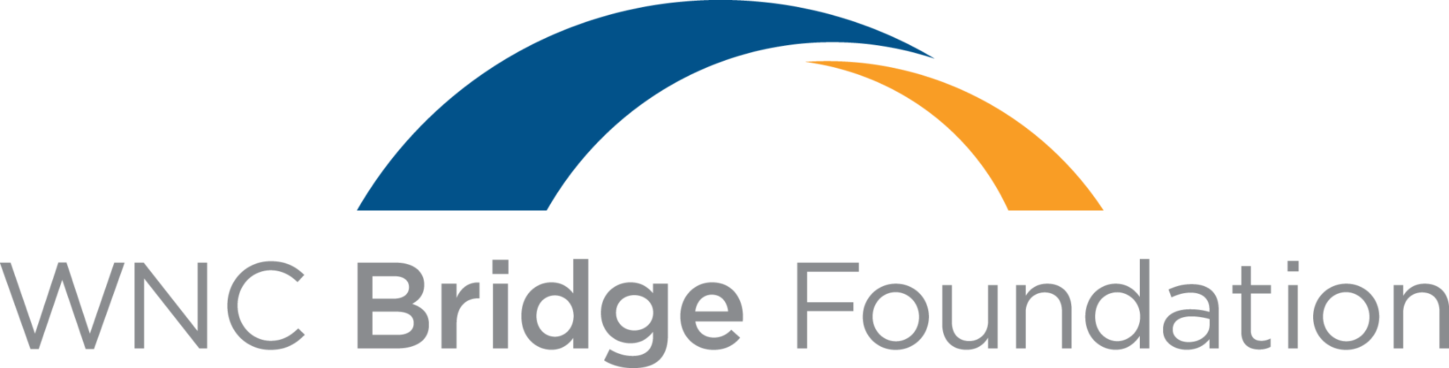
Finance Associate
Build your finance career while making an impact in Western North Carolina.
DEPARTMENT  Finance | REPORTS TO  Vice President, Finance | STATUS  Exempt | LOCATION  Asheville, NC
ABOUT THE OPPORTUNITY
WNC Bridge Foundation is seeking a detail-oriented Finance Associate to support the financial operations behind work that makes a meaningful difference across Western North Carolina. This role offers broad hands-on experience across Accounts Payable, General Ledger Accounting, reporting, audit preparation, forecasting, and grant-related financial analysis.
If you are organized, accurate, collaborative, and interested in growing your finance career within a mission-driven organization, we would love to hear from you.
OUR MISSION
Connecting our communities to a healthier future and creating lasting change through local partnerships.
WHAT YOU'LL DO
You'll help maintain accurate financial records while supporting day-to-day operations, reporting, compliance, planning, and continuous improvement.
ACCOUNTING & FINANCIAL REPORTING  - Prepare month-end journal entries and support month-, quarter-, and year-end close activities.  - Reconcile bank, investment, balance sheet, and general ledger accounts.  - Record bank drafts, prepare deposits, and post donations to the general ledger.  - Manage capital asset acquisition, recording, amortization, and disposal.  ACCOUNTS PAYABLE & VENDOR MANAGEMENT  - Process approved invoices and prepare weekly payment runs.  - Resolve vendor billing and payment questions.  - Maintain vendor documentation, including W-9s and certificates of insurance. | AUDIT, TAX & COMPLIANCE SUPPORT  - Prepare reports and documentation for auditors and tax preparers, including Form 990 support.  - Compile information and complete Sales and Use Tax forms.  - Maintain organized financial records and supporting documentation.  PLANNING, GRANTS & COLLABORATION  - Collaborate with departments to support accurate financial forecasts.  - Apply applicant financial information to ratios used in grant decision-making.  - Participate in Finance process improvement and help strengthen efficiency.

What We're Looking For
You may be a great fit if you bring a combination of accounting fundamentals, strong organization, and a collaborative mindset.
- Bachelor’s degree in Accounting, Finance, or a related field.
- Approximately 1–3 years of accounting experience.
- Working knowledge of generally accepted accounting principles (GAAP).
- Strong attention to detail and a commitment to accuracy.
- Ability to manage priorities independently and meet financial reporting deadlines.
- Strong communication and interpersonal skills.
- Confidence working with accounting systems, spreadsheets, databases, and large amounts of financial data.
- A collaborative mindset, sound judgment, and willingness to learn.
WHY WNC BRIDGE FOUNDATION  Your work supports more than financial statements and transactions.  - Build broad experience across nonprofit finance rather than being limited to one accounting function.  - Gain exposure to audit preparation, forecasting, grant analysis, and financial operations.  - Work closely with organizational leadership and colleagues across departments.  - Contribute ideas that strengthen processes and improve efficiency.  - See how strong financial stewardship supports meaningful community investment across Western North Carolina. | BENEFITS THAT SUPPORT YOU  A well-rounded benefits package  - Medical insurance  - Dental insurance  - Vision insurance  - 401(k) plan with company match  - Company-paid life insurance  - Company-paid disability coverage  - Paid holidays  - Paid time off (PTO)
COMPENSATION
Salary Range: $55,000-$70,000
READY TO MAKE AN IMPACT?
If you are looking for an opportunity to grow your accounting career while contributing to an organization serving Western North Carolina, we encourage you to apply.
Please submit your resume and cover letter to: jbentley@wncbridge.org
EQUAL EMPLOYMENT OPPORTUNITY
WNC Bridge Foundation is an Equal Opportunity Employer and is committed to providing equal employment opportunities to all applicants and employees.

